

K1 CSE3023 PEMBANGUNAN APLIKASI BERASASKAN WEB
LAB REPORT 2
SEMESTER 4

PREPARED FOR: ASSOC. PROF. TS. DR. WAN NURAL JAWAHIR
LAB ASSISTANT: MISS WAN FATIN

PREPARED BY: AKMA ASYIFA BINTI ZULKARNAIE
NO. MATRIC: S75186

Lab Module 2: Servlet – Data Sharing and Database Management
2.9 Exercise

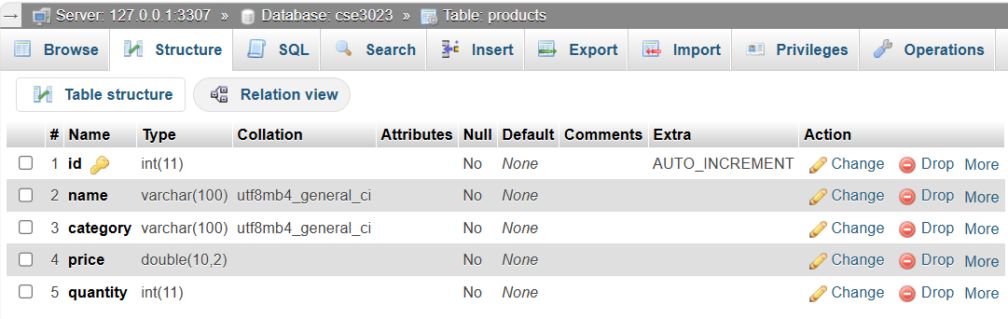
Figure 2.0: Database Setup

Source Code:

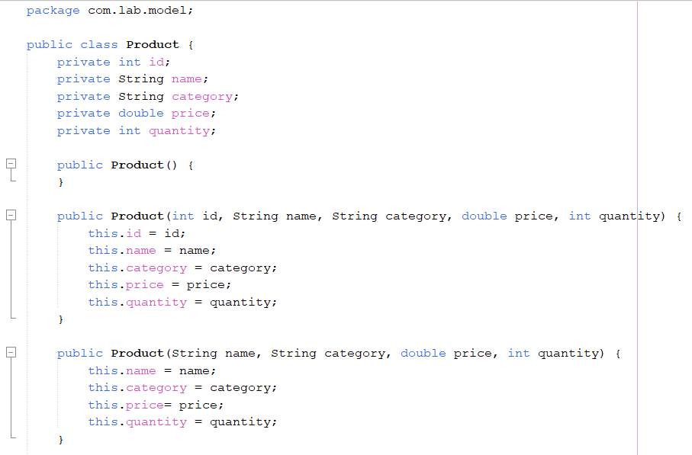
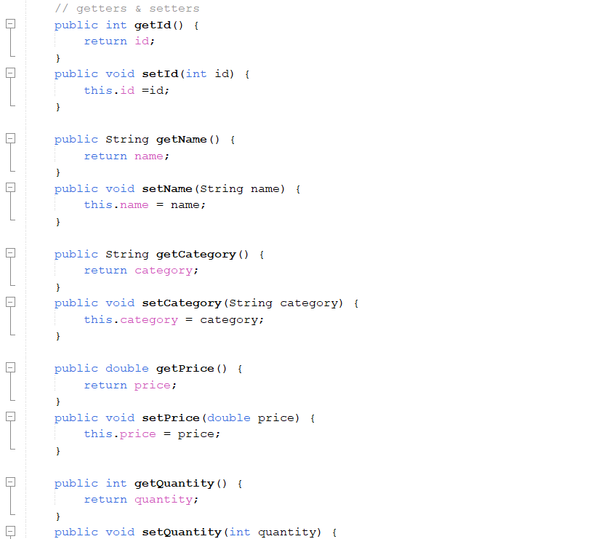
Figure 2.1: Product.java

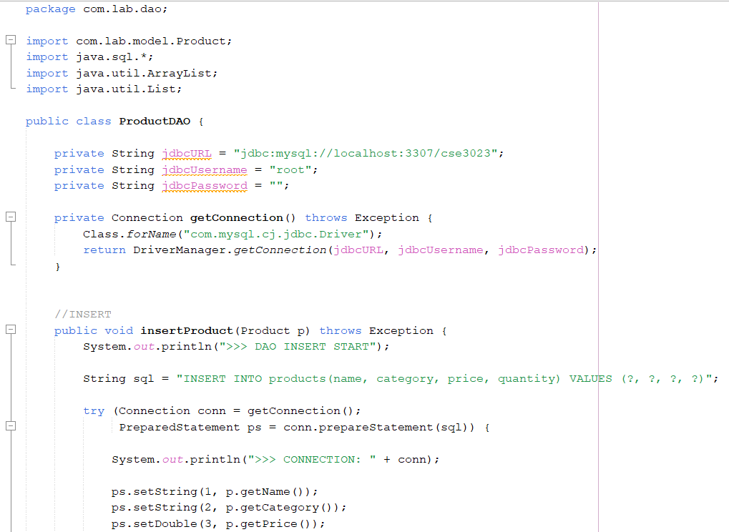

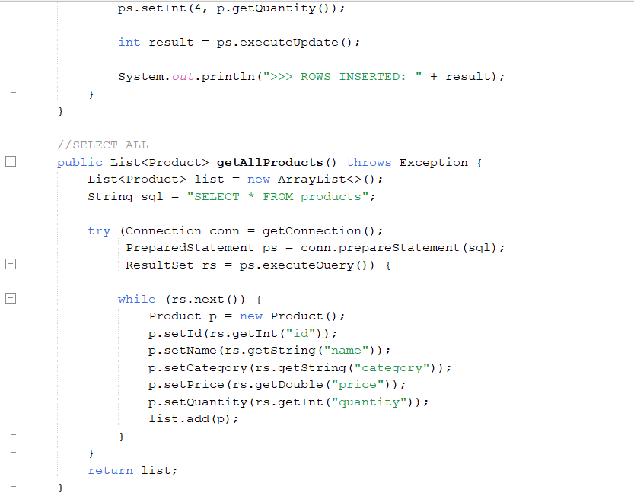
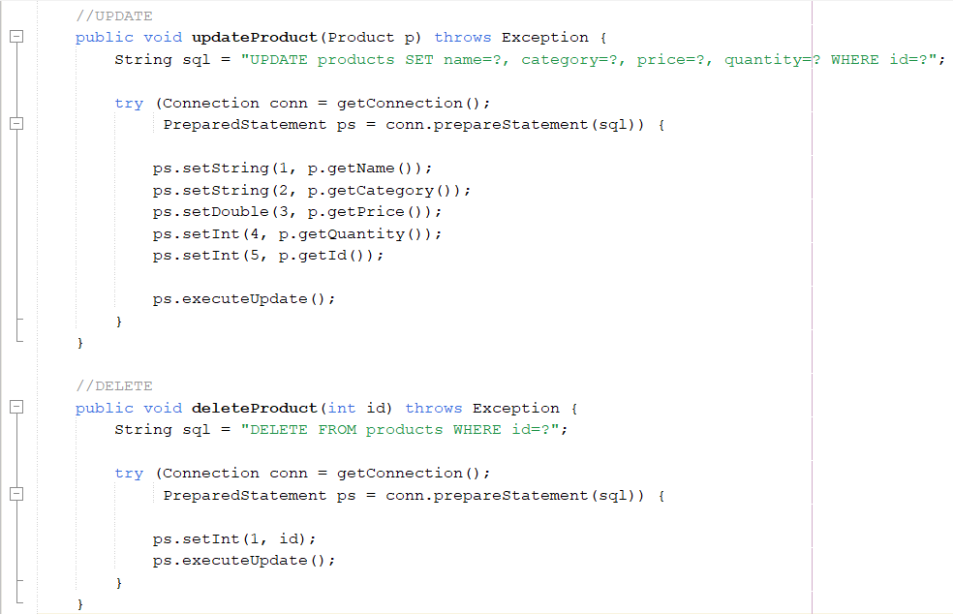
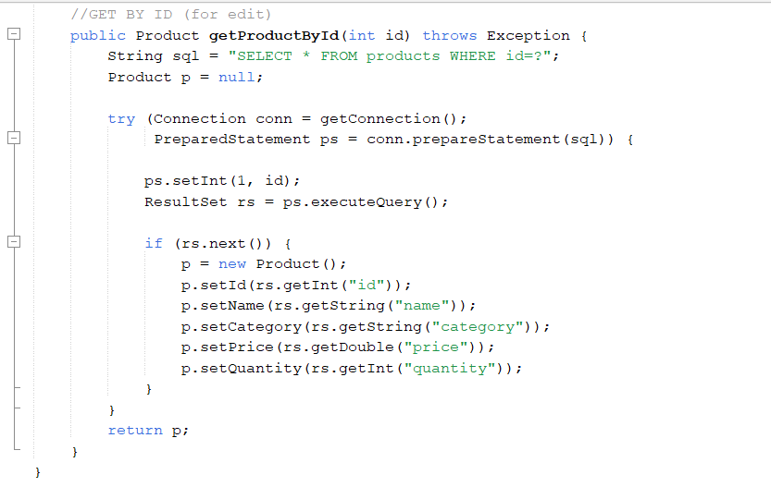
Figure 2.2: ProductDAO.java

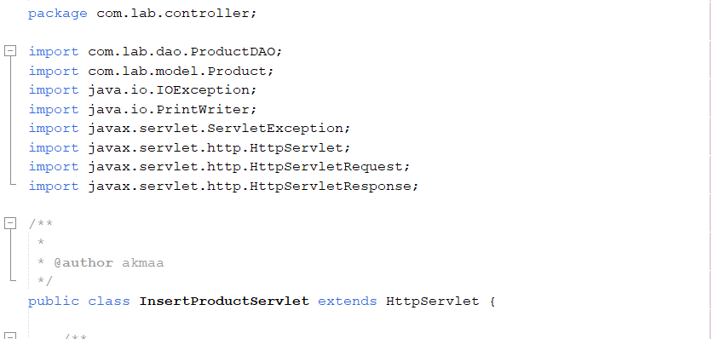
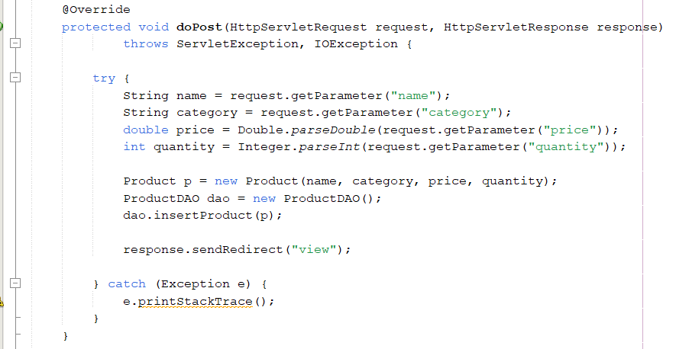
Figure 2.3: InsertProductServlet.java

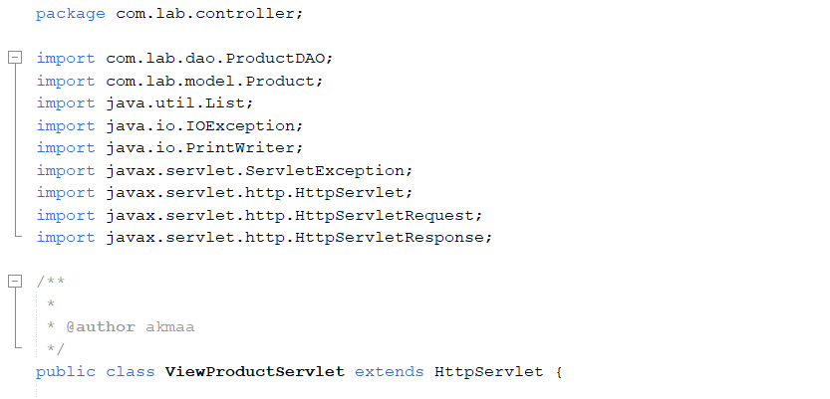
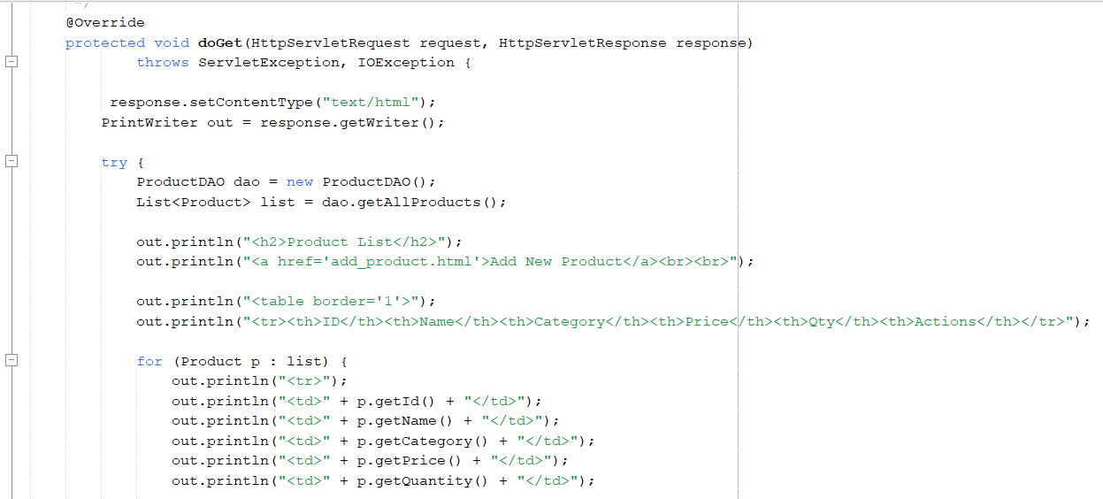
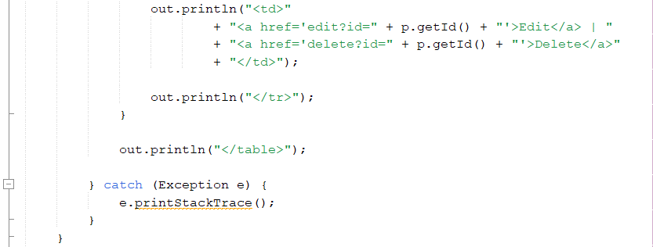
Figure 2.4: ViewProductServlet.java

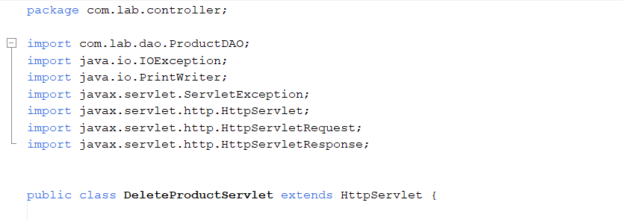
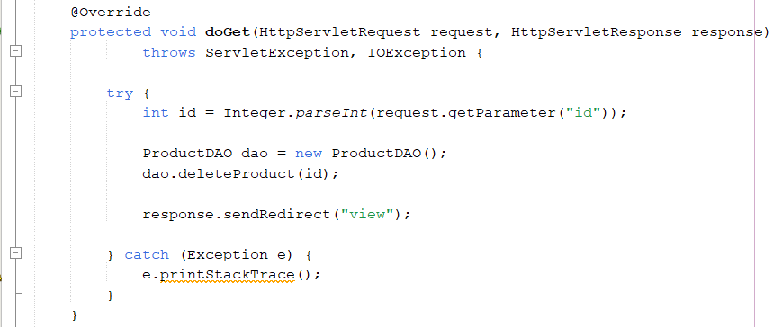
Figure 2.5: DeleteProductServlet.java

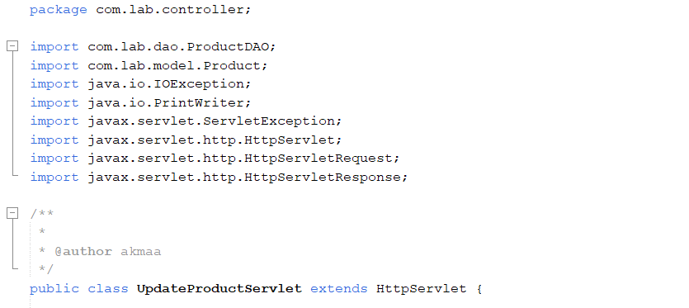
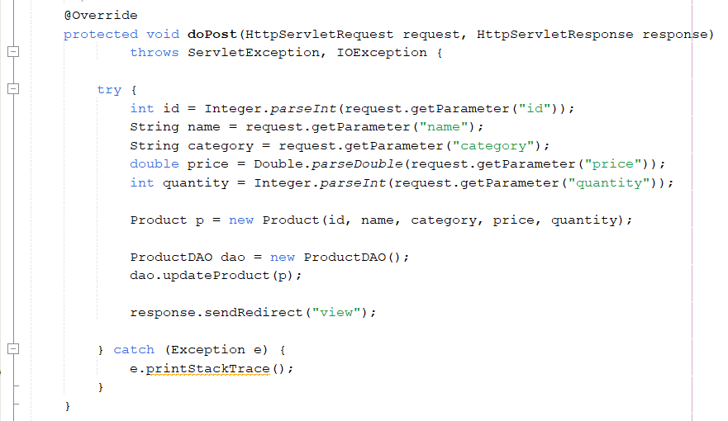
Figure 2.6: UpdateProductServlet.java

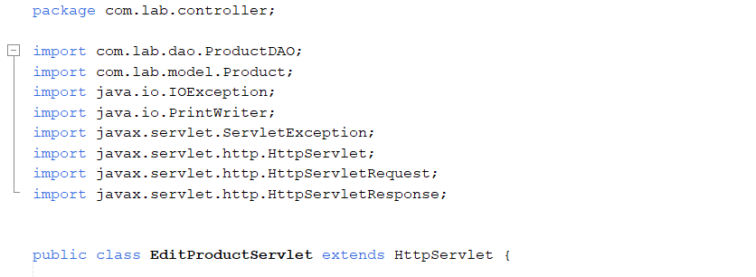

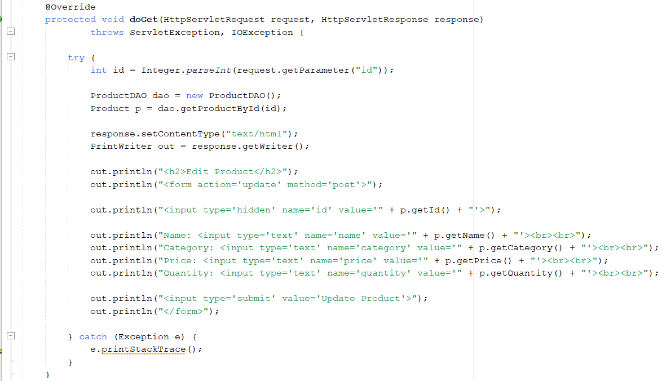
Figure 2.7: EditProductServlet.java

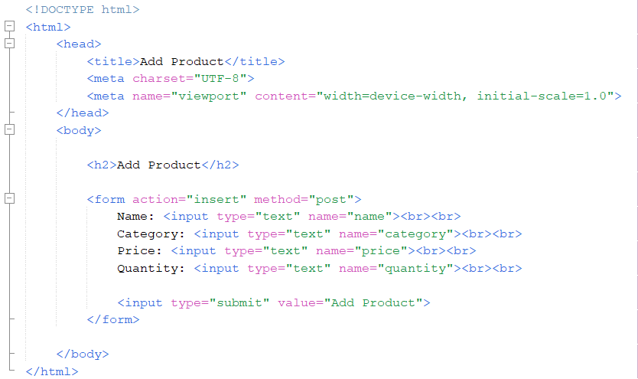
Figure 2.8: add_product.html

Output:

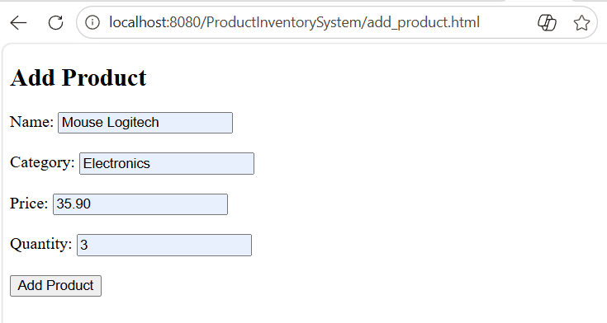
Figure 2.9: Data insertion

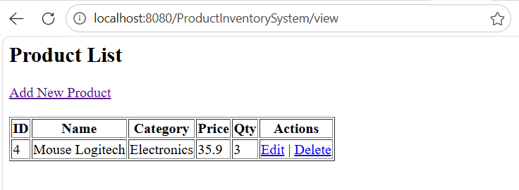
Figure 2.10: Output after add product

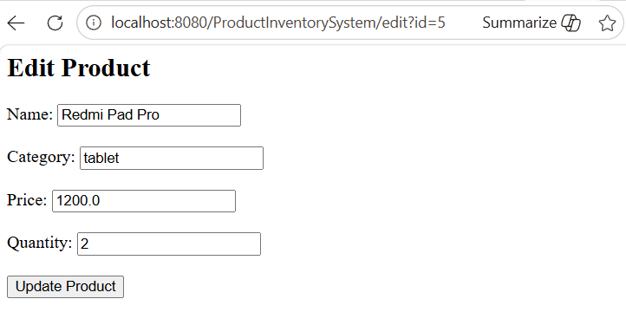
Figure 2.11: Update product

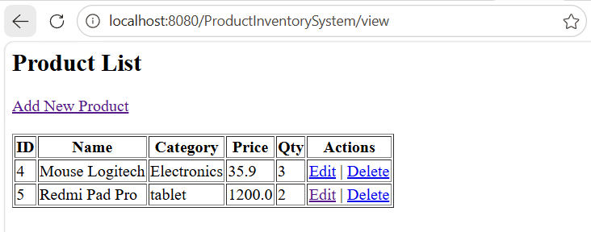
Figure 2.12: Output after update
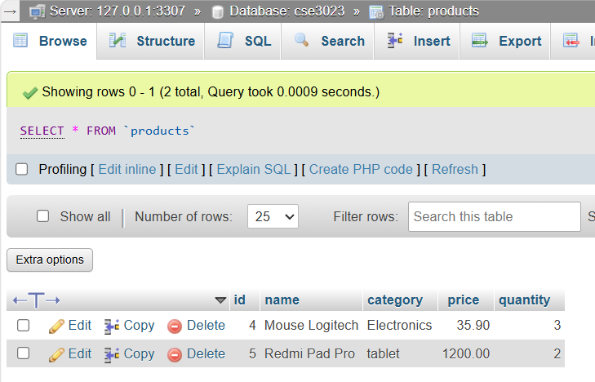
Figure 2.13: MyPhpAdmin Database output

